Licensing/operating system upgrading

By: Jordan Abu-Zahra

Purpose:

the purpose was to get our firewall to the most updated version that we could get so we can stay up to date and be able to keep our device safe.

Background:

The reasons we update firewalls is so that they can defend against all new threats like if you are in a version that was downloaded 5 years ago new threats will be able to get in and steal your information. So, we update to stay safe and keep our information.

Some aspects that we put into keeping ourself safe is getting licenses so that we can choose a level of how secure we want our level of protection to be and if you can have multiple layers of licenses so you can have as much protection as you need to protect yourself and your important data/information and when our expiration date comes up for the license we renew it since if you do not renew it you leave your information from the big enterprise company free game for hackers and pretty much everyone.

Another thing we did in this lab was learning how to update our version for our Pa 220 palo alto firewall since in our world today most things are going digital like even ordering for example you can just door dash your food to your door not having to see a human. This is risky since people on the internet can decide to take what ever they want without being seen. Like when people dox each other or when they steal back account information, a way to prevent this from happening is upgrading your firewall if you have one, in this lab we had to update our Pa 220 from 8.0.32 all the way to 10.2.2-h2 so we could be the most secure and updated as the software would allow us to be.

Reasons we do this is because if you have a non-fully upgraded firewall hackers know the flaws are a well experienced with that version and most likely have a way of getting your information with little to no effort, you will basically be handing over all your data for free and be left with nothing if you make this mistake. With upgrading you get new feature like filtering for example, or your firewall could have a prebuilt in filtering system that kicks out malware that you may not be able to defend against. And when you call for tech support you may not be able to get help since they forgot about what that might do, and they are experts on doing the newest version and you may be stuck with no firewall and be defenseless. But overall, when you think about it giving your device and update and a license renewal is really good for you and you should always keep that in mind

Steps

#1 once you log into your firewall find the license tab on the right

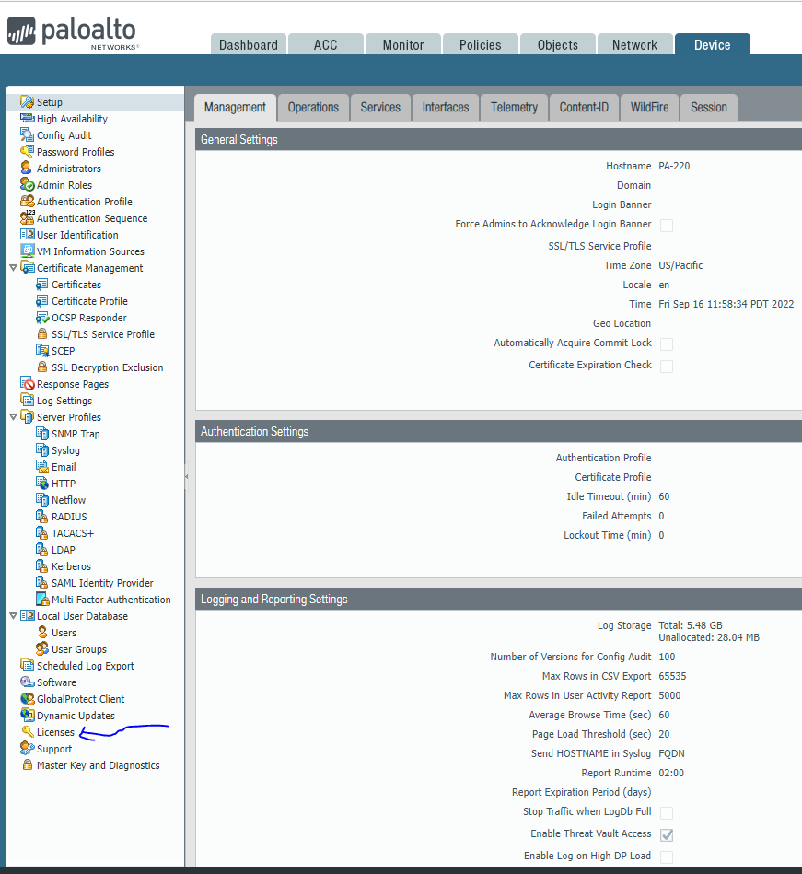

Check your license 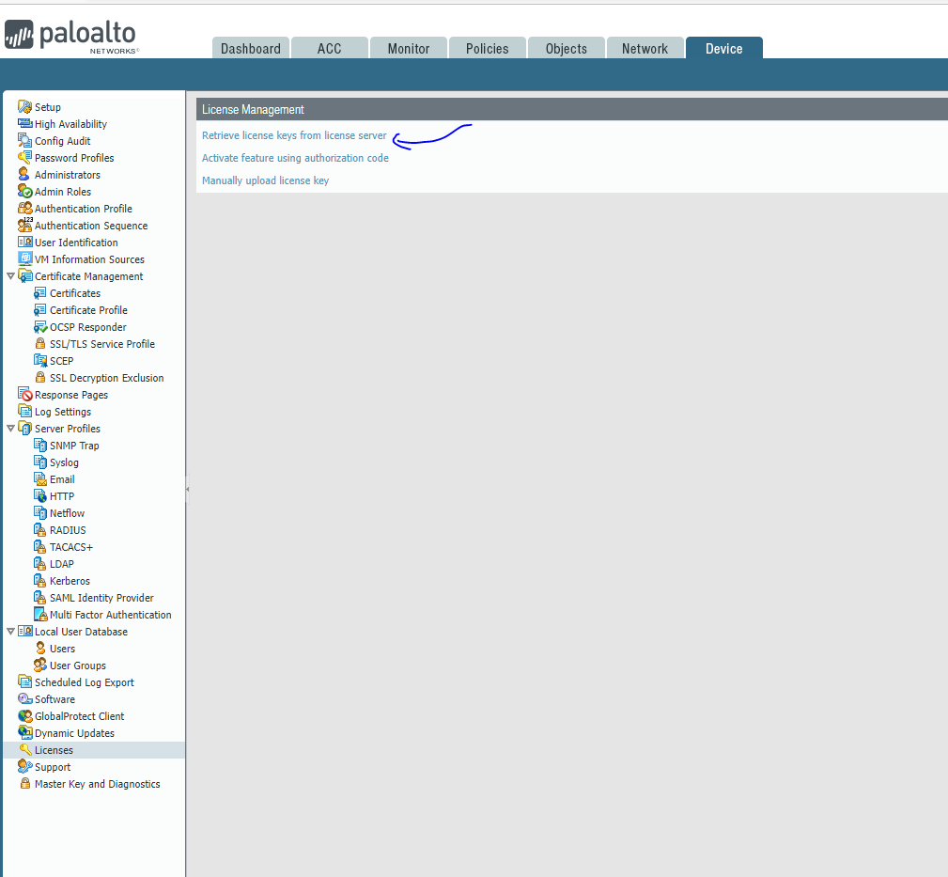

This is the screen you get from clicking “Retrieve license keys from license server”

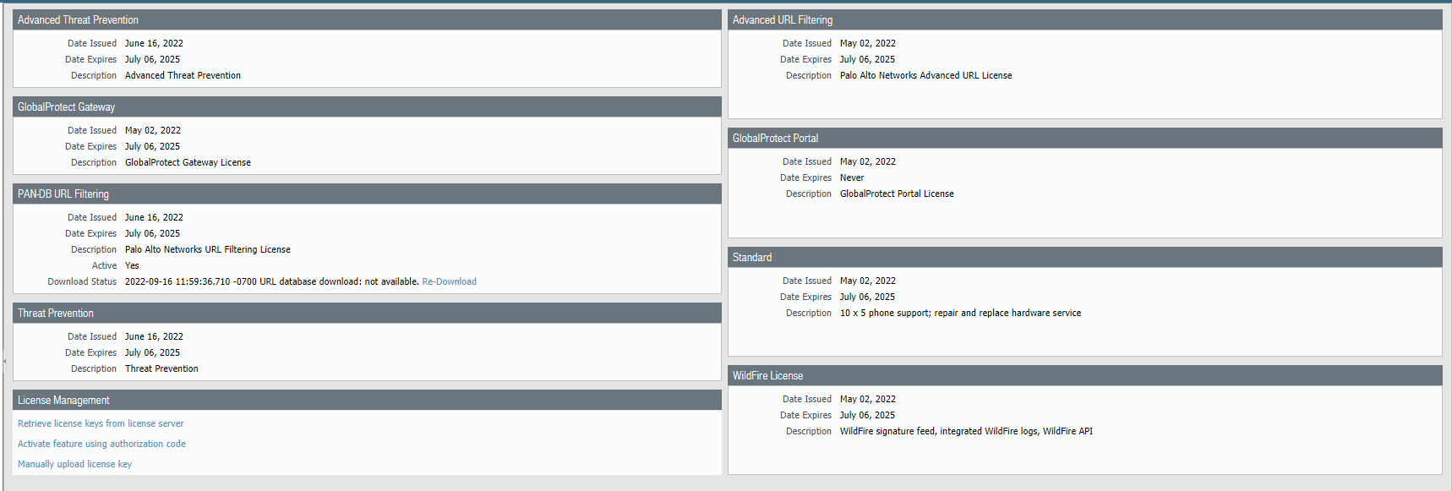

#2 go to dynamic updates and download the highlighted software in the image below

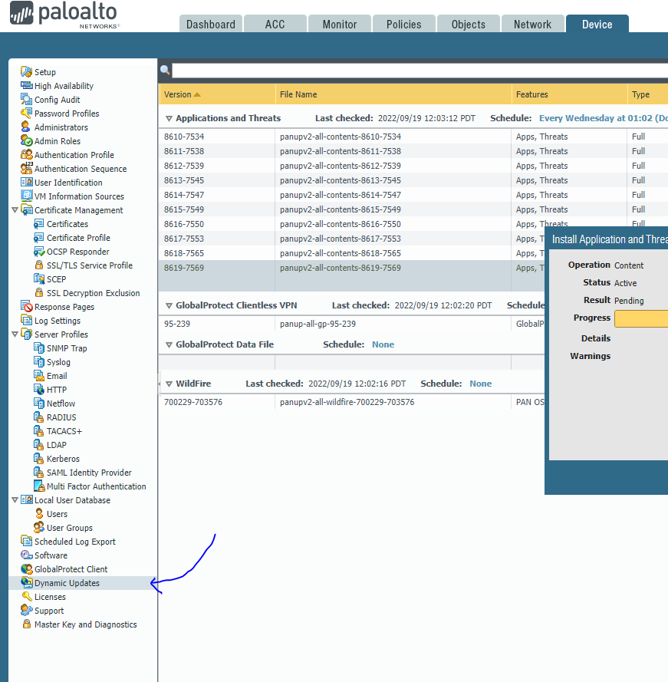

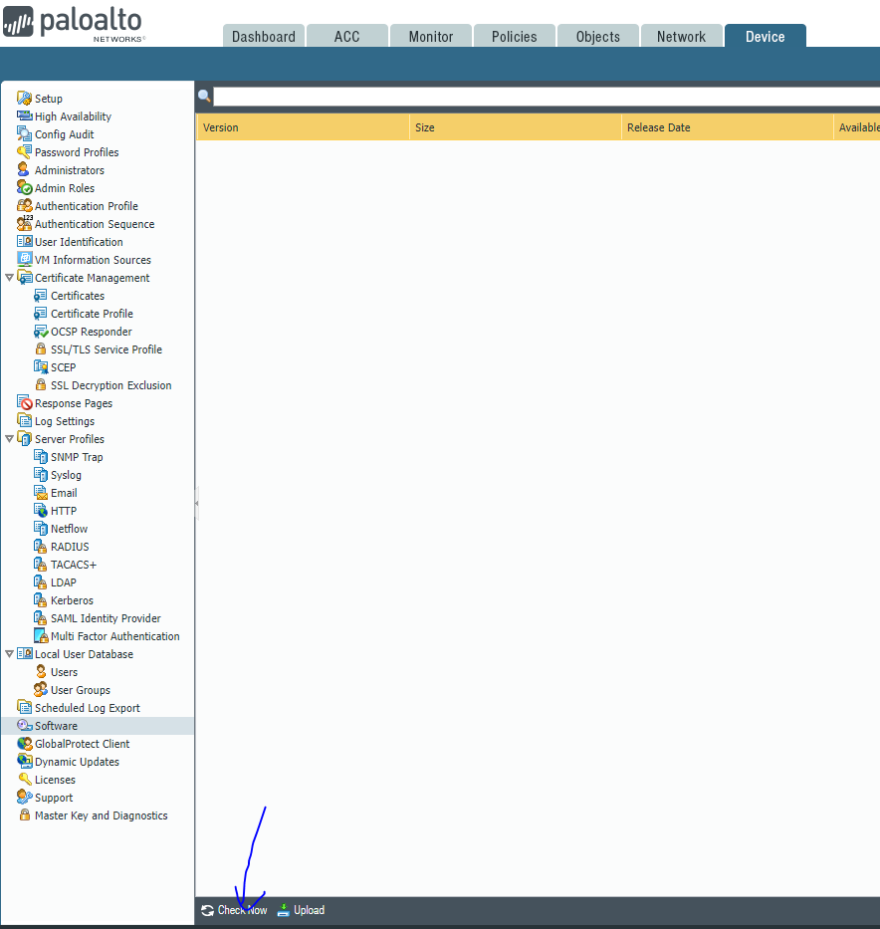#3 go to the software tab and then click check now for updates

#4 check what version you are on then update to the latest version (ex: we were on 8.0.23 so we downloaded 8.1.0 then went to 8.1.22)

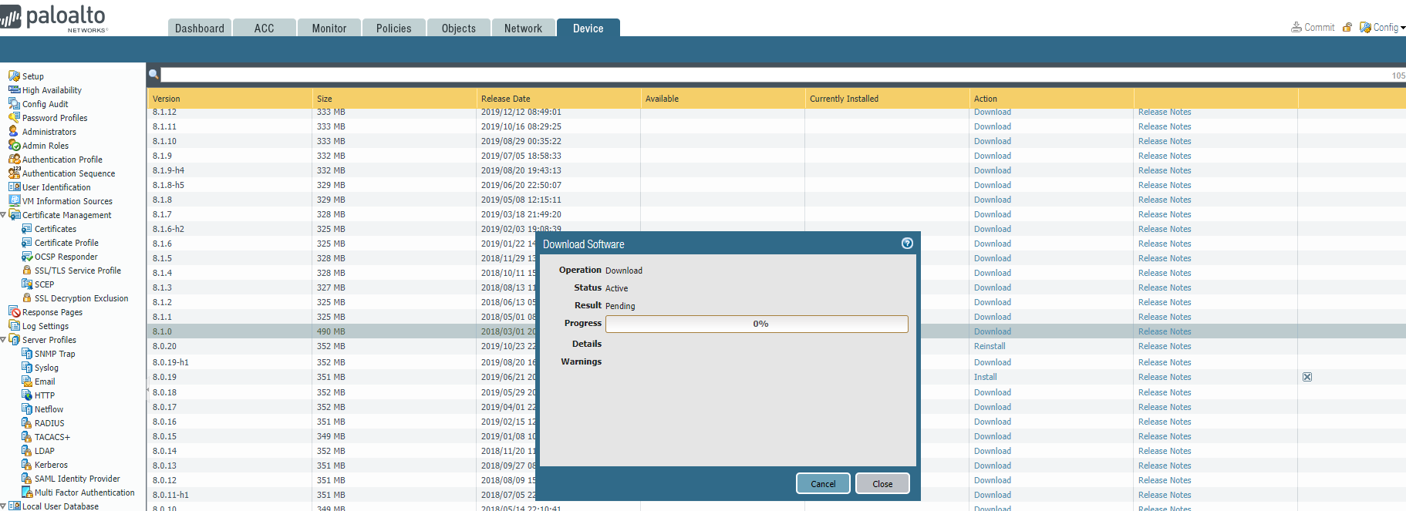

Problems: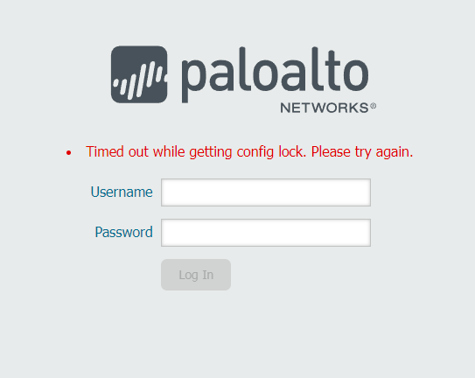

typed in debug software restart process management-server in putty to fix this

Purpose: the purpose of this lab was to learn how to stay up to date on firewalls so we are never on outdated software